How to use the Quizzes
The quizzes in Mathletics are excellent study and practise for each topic. They TEST your skills in each topic, they DO NOT TEACH you the skills. For teaching, see “How to use the learning features”.

To use the quizzes you must first know: 1. Which topic you want to revise
2. Which parts of the topic you have completed so far.
Once you have logged in, click on the topic you are working on/preparing for:
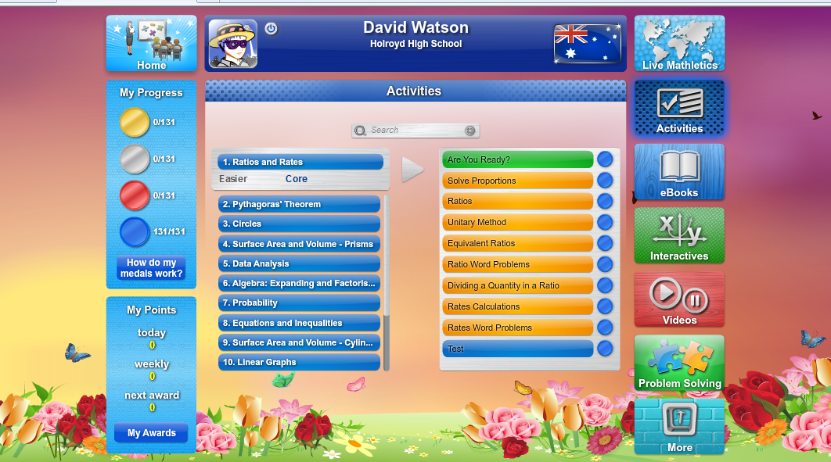
- For easier work, click on the word “easier” under the topic.
- To choose which part of the topic you are interested in, click on it on the right.

- Once you have clicked on the quiz, you will receive 10 questions.
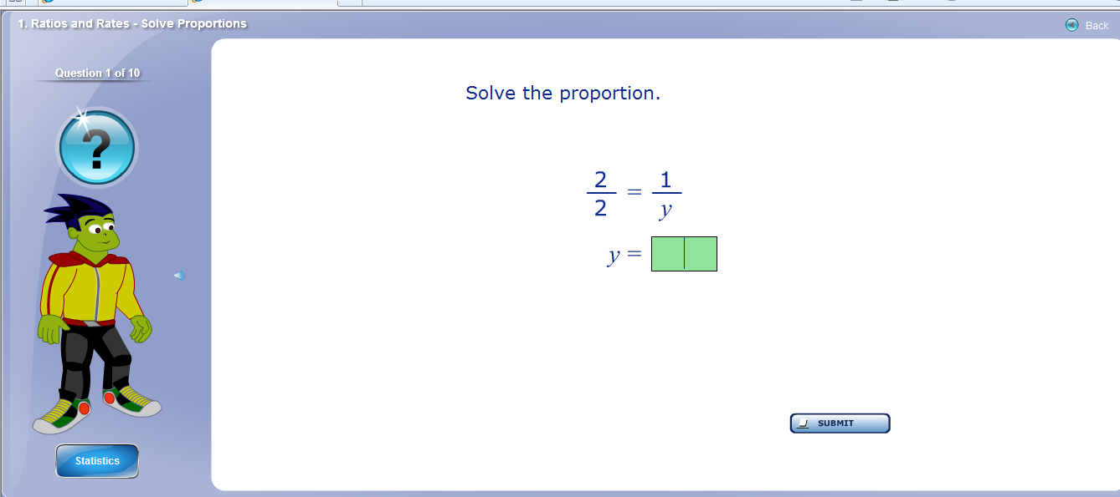
- To answer a question, type it in the box and click “Submit”.
- To get help with the question, click on the question mark.
- To quit the test, click “back”.

- Once you finish all 10 questions, you will get to your results.
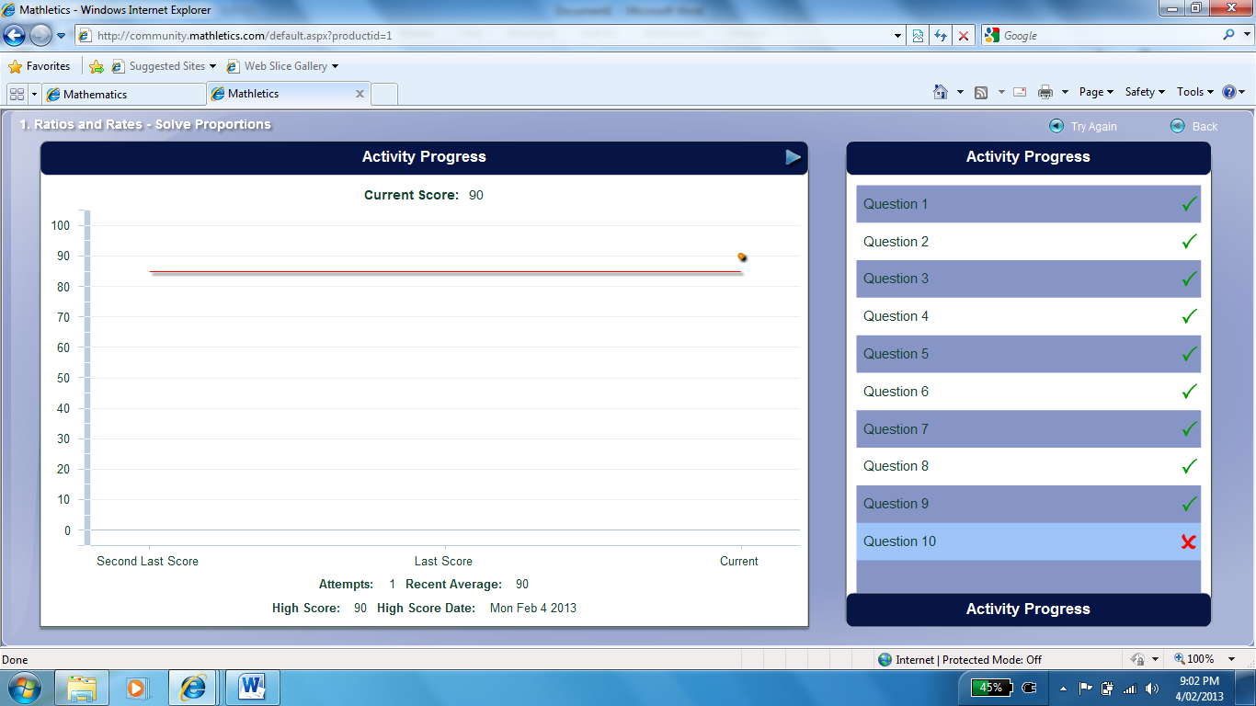
- On this screen you can see the questions you completed correctly or incorrectly. If you click on a question, it will appear again on the screen.

- To see how to do this question, again, click on the question mark.
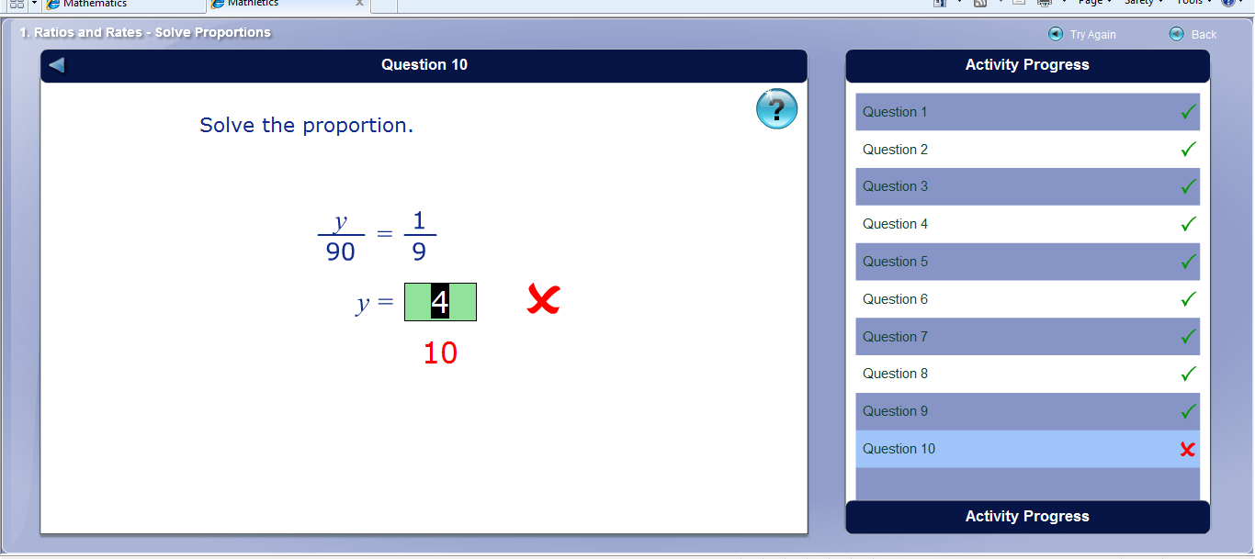
To repeat the test click “Try Again”. To go back to the main screen, click “back”.
- When you get back to the front page, there will be a coin on this test. If it is red, you should try this quiz again.
