How to use the Educational Resources in Mathletics
There are many educational resources in Mathletics to aid your child’s learning. This document shows how to find each resource and best use it to support homework and additional study.
- Workbooks – These replace old style textbooks. To find these, once you have logged in, click on the button to the right that says “ebooks”.
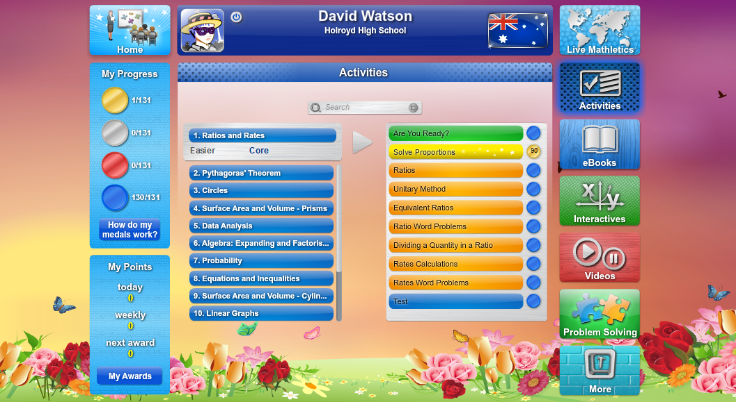
- The screen will change to the one below. Click on the correct year.
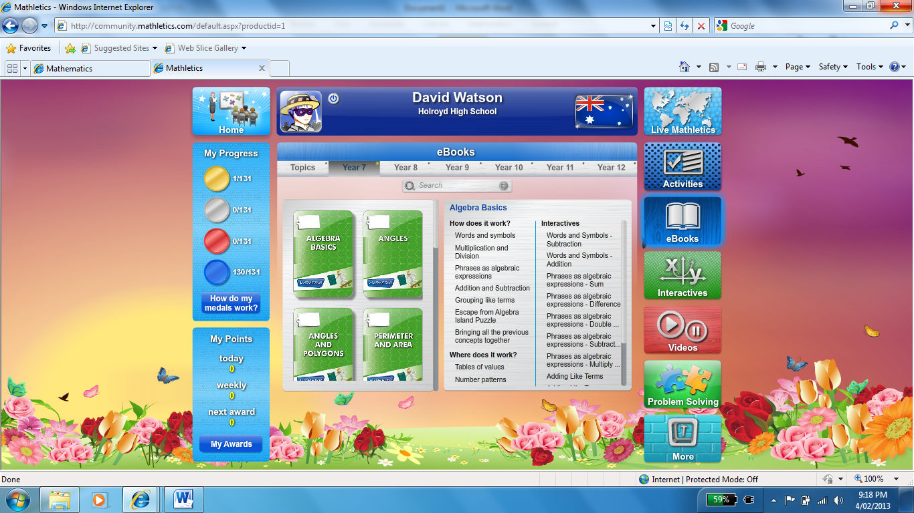
- You now need to choose the correct topic. These are listed on the left.
- Once you have chosen your topic look to the right hand side. You have a number of options in each book.
- There are many files with explanations of mathematical concepts here. Files under the heading “Interactives” include an aspect where students can change the file. Anything under the heading videos is of course a video. An example of an interactive is below.
Click “interact” to use the example.
- This page is part of a whole book on this topic. Scroll to the bottom to see the other pages.
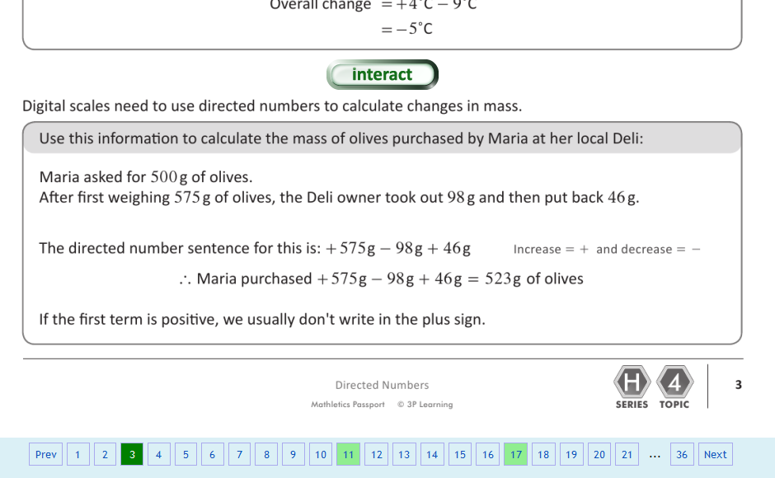
- Green pages have interactive features on them.

